Streambank Erosion Monitoring System

Team 12 - Soil Eroders

Sam Gerdes

Maddie Johnson

Tony Meusch

Megan Pamperin

# Letter of Transmittal

April 1, 2019

Dr. Aaron Mittelstet

University of Nebraska - Lincoln

Biological Systems Engineering Department

Dr. Mittelstet,

We submit the following document as a final report for our BSEN 470/480 senior design project creating a streambank erosion monitoring system. The final design was created based on criteria you presented to us at the start of the project in November, as well as updated information given during our weekly meetings since then.

This report contains a description, pictures, and parts list for the final design as well as background information and design alternatives that lead to the final product. A working prototype was able to be built and data collected from testing this prototype is included in the document as well. This report will allow you to make replicas of the streambank erosion monitoring system prototype created by our group and implement them in the field as you deem necessary for research purposes.



Sincerely,



______________________ __________________________

Sam Gerdes Maddie Johnson



_______________________ __________________________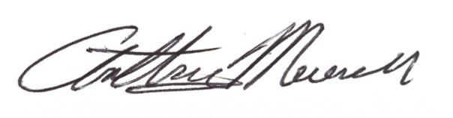

Tony Meusch Megan Pamperin

# Table of Contents

**Abstract** **4**

**Background** **4**

**Problem Statement** **5**

**Design Goals and Deliverables** **5**

**Criteria and Constraints** **5**

**Analysis of Alternatives** **5**

**Final Solution** **6-7**

**References** **7**

**Appendix** **8**

Impact Statement 8

Gantt Chart 8-17

Supporting Data/Drawings 18-19

Bill of Materials 19-20

Arduino Code 20-23

Part Documentation 23

# Tables and Figures

# 

# Abstract

Streambank erosion is a common occurrence along streams in both rural and urban areas and causes issues with sediment load in the water and loss of land around the streams. Currently, this erosion is monitored using bank pin technology, which requires frequent travel into the field to determine the loss of soil from single storm events. This is why there is a need for a more precise monitoring system that can log data directly before, during, and after erosion occurs and has the potential for remote communication to eliminate travel into the field entirely.

After considering many different alternatives for sensing, data logging, design layout, and housing materials, a final design was chosen and a prototype was created. This prototype includes an ultrasonic sensor to measure the distance to the streambank, an Arduino Nano board to write these measurements to a micro SD card, and a battery to power the system. All of these components are housed inside a waterproof box that is mounted on an aluminum pole. The system is created to be able to power and store enough erosion data to last a month.

# Background

Nebraska has more miles of rivers than any state in the U.S., which means streambank erosion is a common occurrence. The more a stream meanders, the more likely it is to experience erosion. Additionally, when there are large storm events, erosion can also increase. Erosion can increase the sediment load in the water as well as disrupt cropland if the erosion is severe enough. For these reasons, it is essential to monitor streambank erosion to protect water sources and the land surrounding the streams.

Typically, streambank erosion is monitored and measured using bank pin technology. This is a rather archaic and cumbersome way to measure streambank erosion. It involves sticking long steel poles, often rebar, into the bank and marking where the bank meets the end of the pole. After large storm events, hydrologists have to go back to the stream to measure the exposed pole to assess the erosion that has occurred. Frequent measuring is a feasible task for local urban streams, but for rural locations, the travel time to get to sites makes it difficult to get readings more often than once per month.

Our client is Dr. Aaron Mittelstet, an assistant professor in the Biological Systems Engineering Department at the University of Nebraska-Lincoln. Dr. Mittelstet performs research surrounding surface and groundwater interactions, water quality, and streambank erosion. He came to our group on the premise that there are currently limited ways to monitor streambank erosion that are effective and accurate, with bank pins being the most common method.

Aside from Dr. Mittelstet, hydrologists and researchers will be able to either use the new erosion monitoring technology or benefit from data collected. Additional stakeholders involved with streambank erosion include landowners, farmers, and others living near unstable streams.

# Problem Statement

Currently, there is no automated way to measure and store streambank erosion data.

# Design Goals and Deliverables

The goal of our project is to create a new device that can monitor stream bank erosion for long periods of time and store that data. This design should have the ability to integrate remote communication in the future to eliminate the need to travel to the field to collect data.

The main deliverable requested by Dr. Mittelstet is a working prototype that can be implemented in the field for testing.

# Criteria and Constraints

There were several criteria laid out by Dr. Mittelstet for this project. The monitoring system needs to have the capability to store gathered data within the device for long periods of time. Resolution is important for this project; it is intended to be accurate up to the millimeter. Given the intended variability of stakeholders for this project, this device should be easy for people to use and install. Because it will be used out in the field near streams, the streambank erosion sensor and system should be water resistant otherwise the electrical components could be damaged. A stand-alone electrical power source is necessary to allow this sensor to be used regardless of where the stream is located. Lastly, there should be the option to easily expand the system to add on remote data communication capabilities.

Only a few constraints exist for this project. The streambank erosion monitoring system needs to collect data every five minutes in the field. This frequency will ensure that all erosion events are captured in the collected measurements. Because it will be used out in the field, the streambank erosion sensor and the system need to be completely waterproof. Without waterproofing, the electrical components could be damaged from rain or condensation.

# Analysis of Alternatives

Before settling on the final design, a number of sensors were considered. Many of the possible sensors were ruled out due to their potential unreliability in the streambank environment. Early ideas considered light, temperature, or pressure sensors embedded in a rod which could be driven into the bank. These sensors were ruled out as soil could accumulate on top of the device, even when the bank was exposed at that position, and produce false readings from the sensors. In addition, the embedded sensor rod design necessitated an array of sensors down its length to function, and if just one of those sensors failed, it would result in a false reading. To mitigate this risk, ultrasonic sensing was proposed. By using ultrasonic sensing, one sensor reads the distance to a particular point on the bank, resulting in a readily scalable sensor array where sensors are not dependent on one another.

In addition to an abundance of sensing options, there were also a number of apparatus mounting options. For instance, the sensor could be mounted downward at the bank from the top, horizontally toward the bank, or angled from the opposite bank (shown in Supporting Data/Drawings). Figure 1 shows the horizontal option, which would lead to stability issues as the bank eroded backward. With this design, it would be difficult to embed a rod far enough into the bank to ensure that the system wouldn’t fall out after severe erosion. Figure 2 shows the vertical option, where a rod would be placed vertically into the eroding stream bank and the sensor hung over the edge and pointed back towards the bank. The problem with this design is also that severe erosion could expose the rod. Additionally, this option and the horizontal option could potentially be submerged during large storm events if the stream height rose enough. A vertical option to take vertical readings of the distance to the bank is shown in Figure 3, which would have no risk of submerging the sensor underwater. However, vertical readings may not give accurate data on the amount of erosion because streams usually erode horizontally, away from the water. The last option for mounting the sensor and housing is a vertical rod with the sensor aimed to take readings at the opposite bank, shown in Figure 4. This design would correctly pick up changes in the streambank due to erosion and would not be at risk of being submerged, but it would also be limited to only measuring erosion on streams with a width less than the range of the ultrasonic sensor being used.

The last set of design alternatives is related to the electronic components required to log data. The main choices for collecting readings from the sensor were a myDAQ device, an Arduino Uno, or an Arduino Nano. The myDAQ is a data acquisition device that is compatible with the LabVIEW programming software. LabVIEW can be used in conjunction with myDAQ to easily visualize data from sensors using graphs but must be run through a computer. The myDAQ device does not function well as a standalone data logger when functioning on its own. The Arduino Uno is a microcontroller board that is compatible with Arduino programming (which utilizes the C and C++ programming languages). This board has 14 digital input/output pins, 6 analog input pins, and a USB connection among other features. The main problem with the Arduino Uno is that it draws 45 mA of current, which will consume a lot of power and limit the amount of time that data can be collected in the field without needing to replace a battery. The Arduino Nano is also compatible with Arduino programming but is a much smaller board. It contains the same number of digital and analog pins as the Uno as well as a USB connection but has fewer extraneous features not necessary for this project. The Nano draws less current than the Uno at only 20mA which is beneficial for battery usage purposes as stated before.

# Final Solution

For the final design, an angled across bank system was chosen. This system should offer structural stability in a location which will have a low to negligible flood risk. The system features an aluminum pipe mount, a variable angle sensor mount, and a watertight energy and data storage housing unit, as depicted in Figure 4. Using the chosen ultrasonic sensor (MB7389 HRXL-MaxSonar-WRMT) the system is capable of outputting a distance measurement with a one-millimeter precision. With this sensor, it is important to stay within the operating range (the measurable range between the sensor and the target area) of 1-16 feet. If desired for use on wider streams, a different version of the same sensor (with part number MB7386) is available with a range of 1-32 feet. To collate the data, the sensor’s serial output is routed to an Arduino Nano, which boots, averages 50 measurements, saves the data and timestamp on the SD card unit, and returns to sleep mode every five minutes. This interval for sleep mode can be changed easily within the code. In order to power the sensing system, a long-duration battery bank is used to supply five volts to the system. It is essential that the battery does not turn off when it does not register a current pull (as some fast-charging banks meant for cell phone charging are designed to do). A recommended battery is the 18,200 mAh Griffin Reserve Power Bank, listed in the bill of materials in the appendix.

The selected MB7389 sensor has seven input/output pins, though only four are used in this design (See the appendix for the full data sheet). Pin 4 (Ranging Start/Stop) is connected to the TX serial output pin on the Arduino Nano and is used to start or stop the sensor to take readings. Pin 5 (Serial Output) is connected to the RX serial input pin on the Nano and sends the distance reading to the board in millimeters. Pin 6 (Positive Power) and Pin 7 (Ground) are connected to the 5V and ground pins on the Nano, respectively. It should be noted that one of the unused pins on the sensor is a temperature sensor connection that could be used to enable the temperature compensation feature of the device.

Also connected to the Arduino Nano is an RTC (real-time clock) module, specifically the DS3231 from Adafruit, and an SD card module from Gikfun. The RTC is used to keep time and log the time that each reading from the sensor is taken. The Nano then writes both the time and the reading measurement onto a microSD card held in the SD card module. Whenever the data is ready to be collected, the Arduino board can simply be unplugged from the battery bank and the microSD card can be ejected from the module without harming the system. To download the data onto a computer, the microSD needs to be placed in the SD adapter and inserted into a computer SD card slot. The SD Card file will be titled “DATA” and is a .txt file that can be exported into Excel for data analysis.

# Testing Results

There were three rounds of testing for the final solution. The first testing period consisted of installing the device along a tributary of Stevens Creek at Rogers Farm (owned by UNL). See Figures 1 and 2 for a picture of the installation. The 5,200 mAh battery pack that was used lasted for 76 hours without cycling into power down mode, which means that the average current draw of the system was 68.4 mA. There were many erroneous data points collected with values above the 5000 mm maximum output of the sensor, which could have been due to the voltage supply to the sensor or the frequency of sensor readings. Figure 3 shows a period of about 14 hours shortly after the device was first installed in the field that doesn’t have many reading errors. At the 12 hour mark it can be seen that the distance to the streambank increased which indicates erosion, and indeed it was raining at this time. However, after this the distance to the bank drops. One explanation for this could be that soil from higher up on the streambank fell into the area that the sensor was pointed at. Another explanation could be that the aluminum pole that the system is mounted on was not stable in the ground and leaned forward after the rain. Even though there were errors found in the testing, the current draw information was quite helpful moving forward. Also, the accuracy of the system was confirmed; the data collected in Figure 3 is within a 40 mm range.

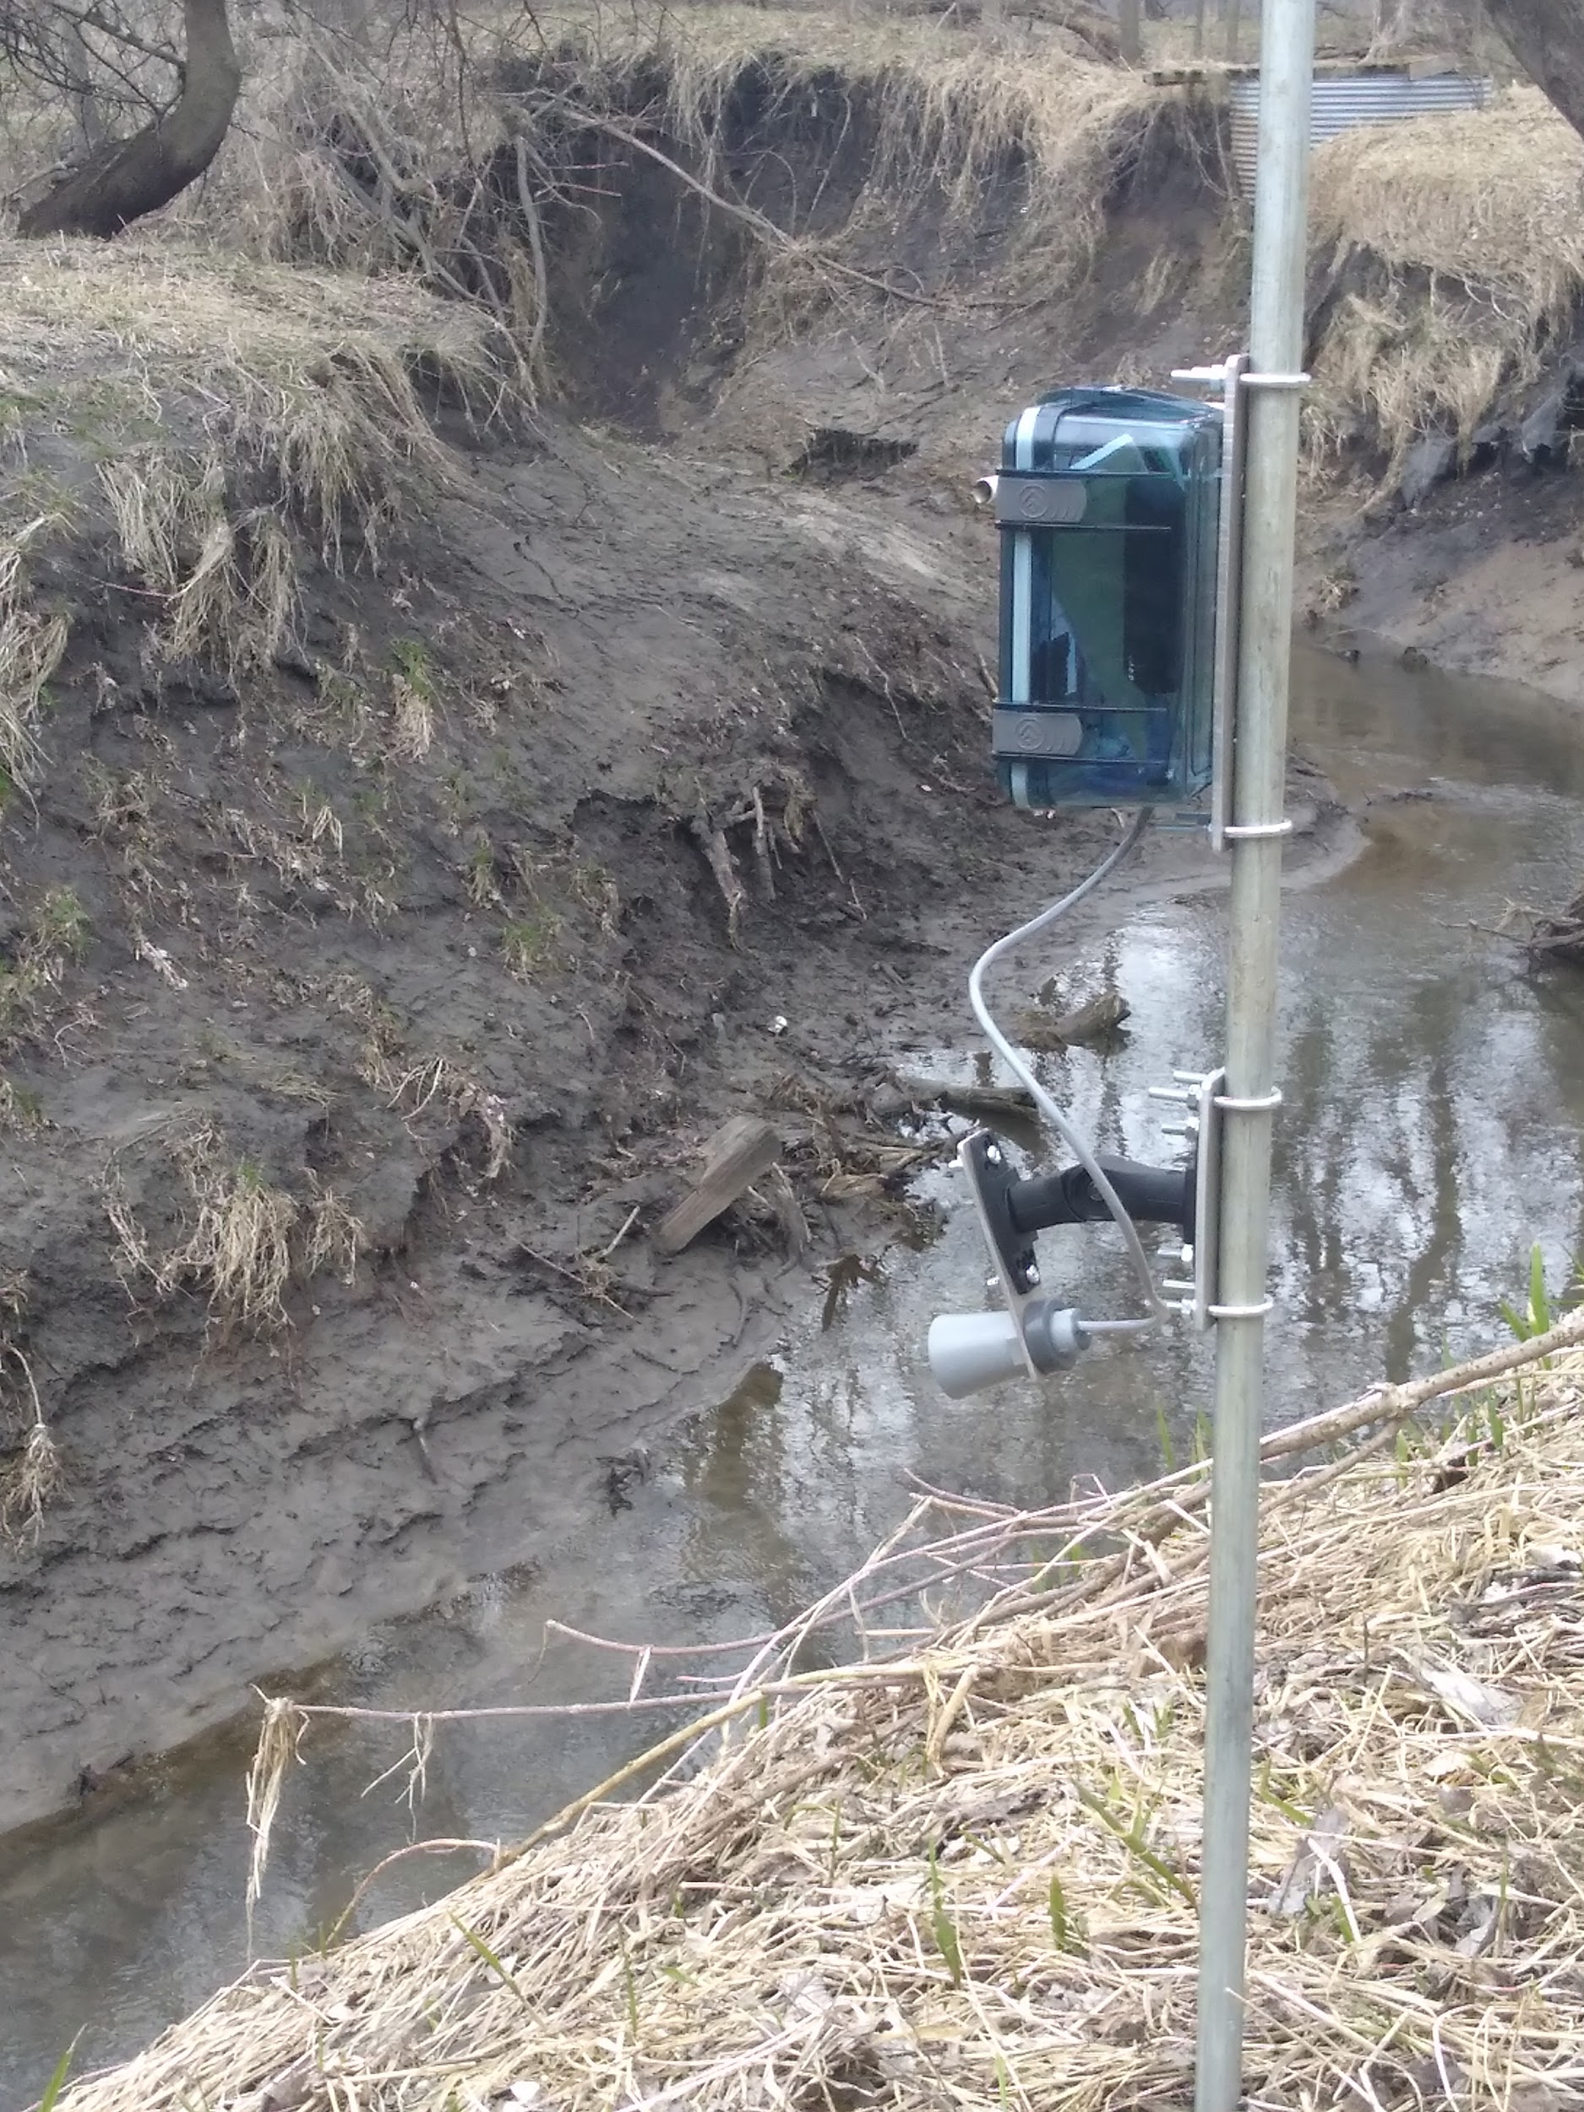 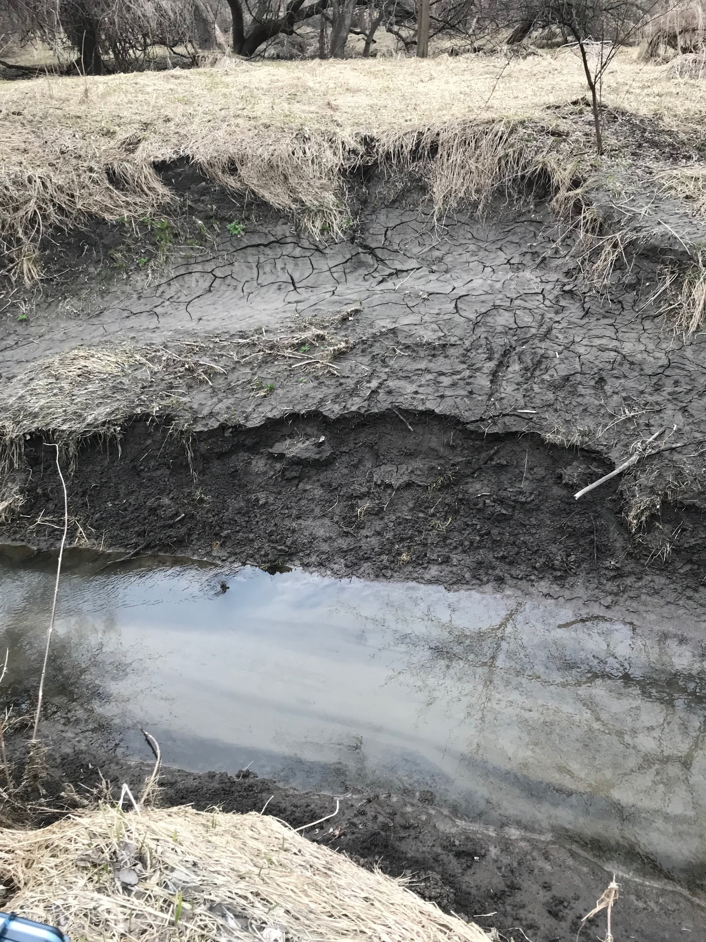

Figure 1. The final design installed in the field. Figure 2. The sensor was pointed at this bank just

above the water level.

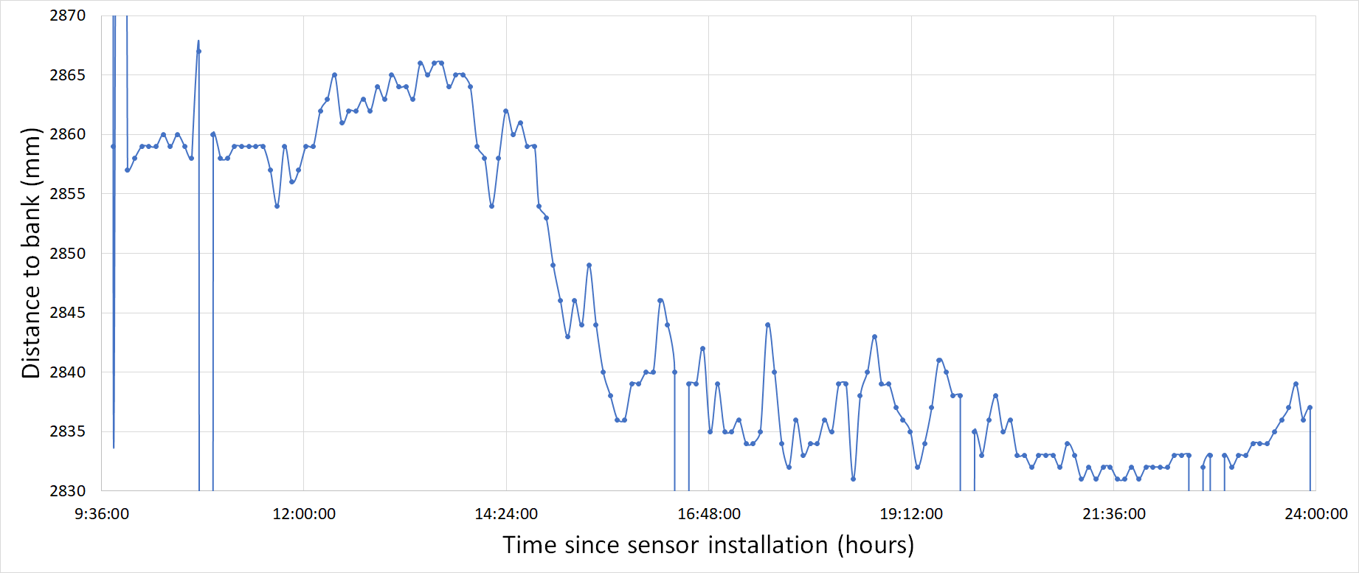

Figure 3. Section of the sensor data gathered from testing at Roger’s Farm.

The purpose of the second round of testing was to make sure that the false reading errors had been fixed and to see the improvement in current draw when power cycling was used. For this testing the sensor was simply pointed towards a wall in the back of a classroom in Chase Hall on East Campus, and was moved backwards twice during the testing period. The results are shown in Figure 4 below. The false reading issue was solved due to additional lines of code to throw out errors, and the two movements of the sensor away from the wall can be seen very clearly as steps in the graph. The power cycling extended the battery life to 110 hours (or 4.5 days). Using the recommended 18,200 mAh would extend the life of the system to about two weeks.

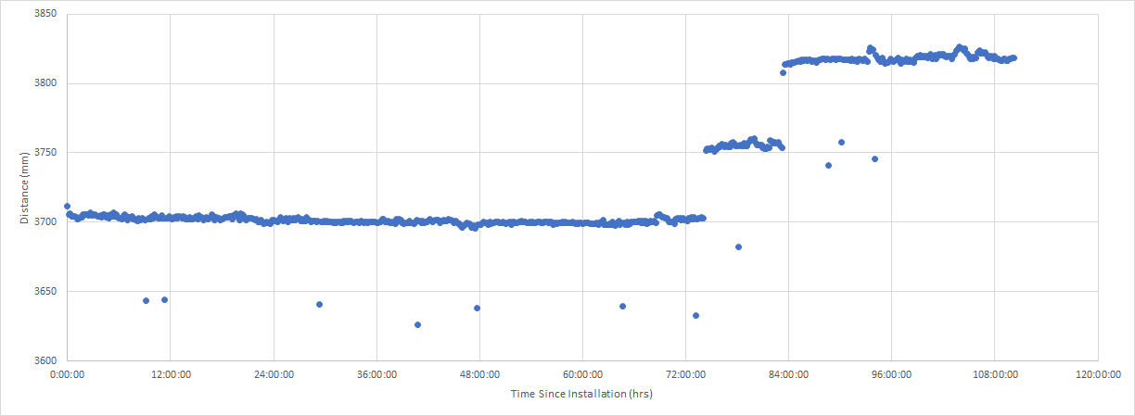

Figure 4. Sensor data gathered from testing in Chase Hall.

The third and final round of testing was set up in the Soils Lab in Chase Hall on UNL’s East Campus. The aluminum pole with the sensor attached was placed horizontally on a ladder, and the sensor was pointed downward at a box full of sandy soil (see Figure 5). This test was run for about 24 hours. Three times the soil was disturbed, and each of these changes can be seen in the graph of the data in Figure 6. The first two changes were pushing the soil towards the side of the box to simulate erosion in the location that the sensor was pointed at. The second change especially was quite small, and the sensor picked up the 6 mm change with high accuracy. The last change was adding more soil that was sloped downward in the area that the sensor was pointed at. The sensor registered the distance change, but it was not very accurate especially for the first hour or so after this change. This could mean that the soil was still shifting during this time, or it was difficult for the sensor to read a single distance when it is pointed at a slope.

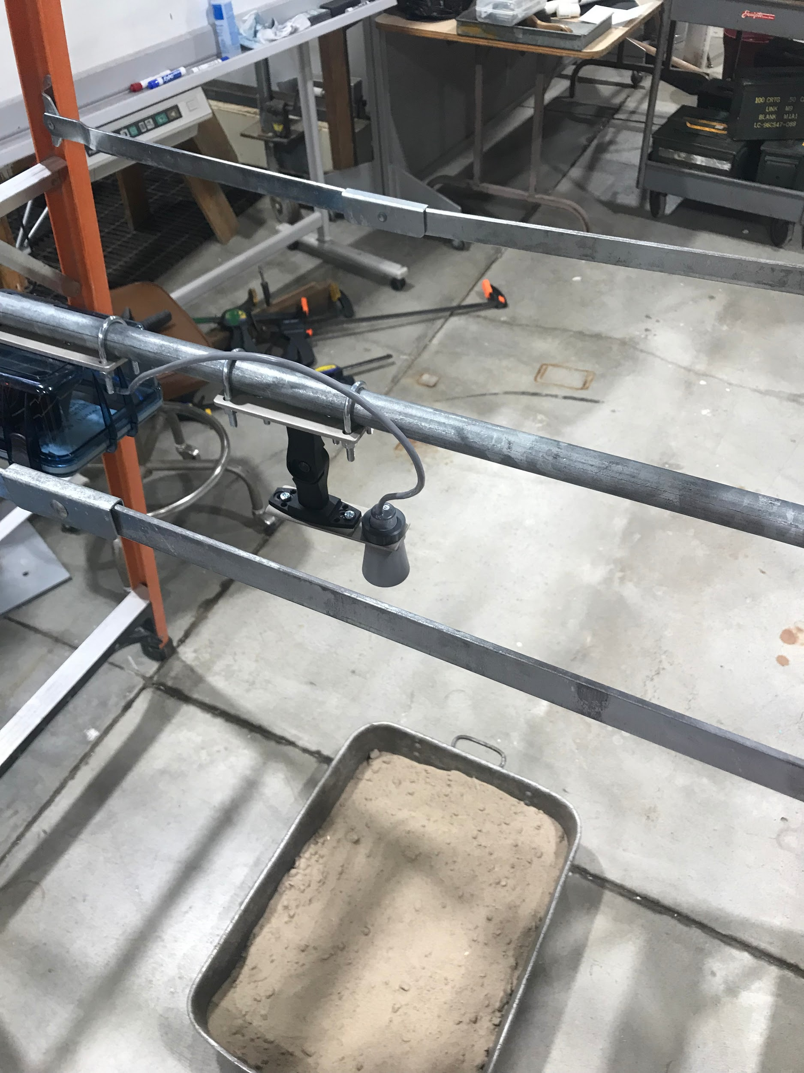 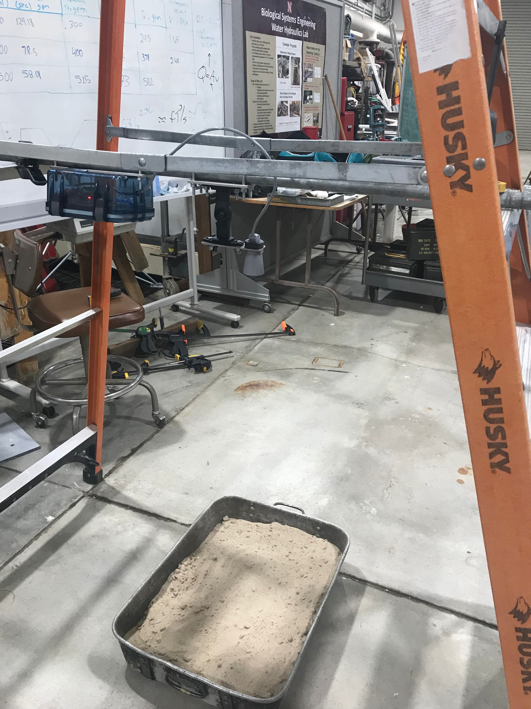

Figure 5. The setup of the sensor in the Soils Lab.

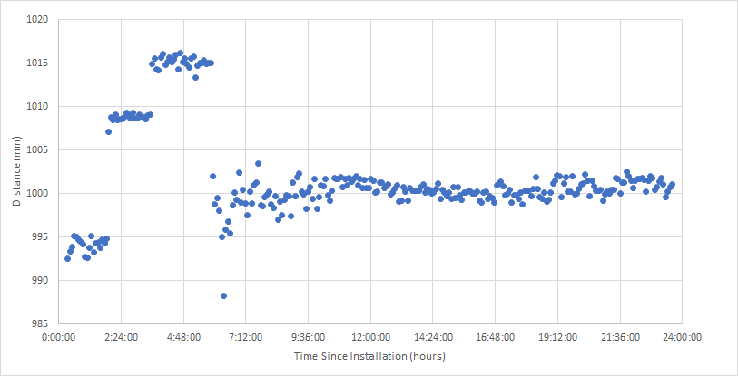

Figure 6. Sensor data gathered from testing in the Soils Lab.

# Further Applications

Expansion of the system is designed to be simple, the current system is capable of supporting five sensors with minimal changes to the measurement and storage code. Additionally, the variable angle sensor mounts can easily be directed at any vertical point on the opposing bank through aim approximation with a laser pointer. The only major system adjustment that comes with expansion is the widening of the sensor mount plate and additional drilling into the power and data housing to feed the extra wiring through. Further, the array will draw more power, so a larger battery bank must be assessed if comparable battery life is desired. If more than five sensors are desired, a larger Arduino board is suggested to supply additional ports, though this also reduces the battery life of the system.

To eliminate the problems associated with using stand-alone batteries to power the system, a solar panel could be used to create power for much longer periods of time. Combining solar panels with remote communication would eliminate the need to physically go out into the field to gather data altogether. A recommended part to achieve this remote communication is the SIM900 GPRS GSM Shield, which is compatible with Arduino boards and will allow data to be sent to phones or computers.

# References

Cook, J. (2018). Ultrasonic Sensors: How They Work (and How to Use Them with Arduino).

Language Reference. (n.d.). Retrieved from https://www.arduino.cc/reference/en/

Santos, S. (2018). Arduino Temperature Data Logger. Retrieved from https://randomnerdtutorials.com/arduino-temperature-data-logger-with-sd-card-module/

Zaimes, G.N., Iakovoglou, V., Koutalakis, P., Ioannou, K., Kosmadakis, I., Tsardaklis, P., & Laopoulos, T. (2015). The Automated Soil Erosion Monitoring System ( ASEMS ).

[Zaimes, G. N.](https://www.cabdirect.org/cabdirect/search/?q=au%3a%22Zaimes%2c+G.+N.%22) (2017). Utilizing New and Innovative Tools to Mitigate Surficial Erosion in Mediterranean Environments.

# 

# 

# 

# 

# 

# Appendix

## Impact Statement

This senior design project, Streambank Erosion Monitoring, potentially has an impact on a variety of areas and people. In the context of public health, our project is intended to monitor streambank erosion which can impact water quality. Nutrients in the soil of the streambank can erode into the water supply. The water can affect downstream water quality for citizens. Within the context of public safety, this project can impact landowners or citizens in a positive way. Erosion can cause homes to be lost directly or through drainage issues. The current method of monitoring streambank erosion, bank pins, can be unsafe to those installing them. Individuals must enter the stream facing risks from unstable streambanks and moving water. This Streambank Erosion Monitoring Sensor can allow for safer installation without risking human safety. Individuals can implement this device outside of the stream and outside of physical harm. Additionally, being able to remotely sense the erosion would allow for warning signals to be sent to the surrounding areas to alert residents when banks are unstable, specifically during large storm events.

The global factors affecting this project include all the bodies of water worldwide that this device could be implemented. While creating this project, considerations for the best possible sensor needed to be taken because of the wide range of stream sizes. To make the sensor as universal and ‘global’ as possible, it is necessary to have a sensor that can be used on a wide variety of different stream sizes.

From an economic standpoint, the current methods are either cheap, simple and time-consuming or very expensive and limited to certain companies. This device needed to be affordable for various people whether it be hydrologists, researchers, or landowners. The goal of this project was to keep the total costs of all components within $400. From there, further expansion can be done to improve the device.

## Gantt Chart

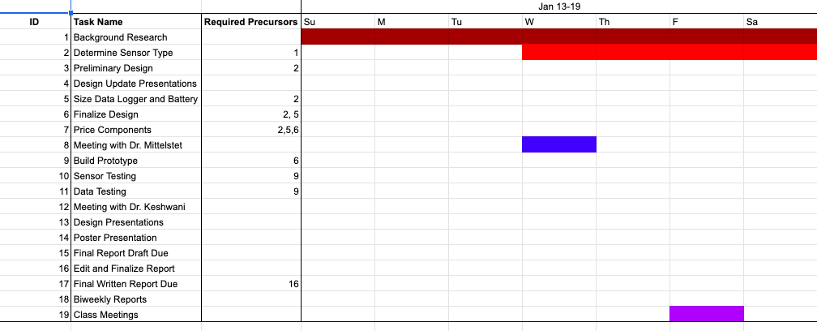

## 

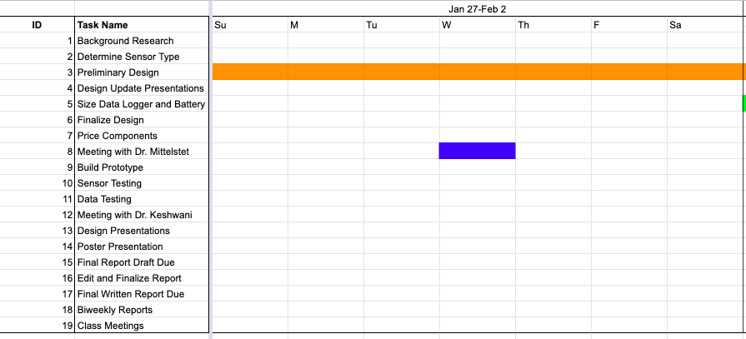

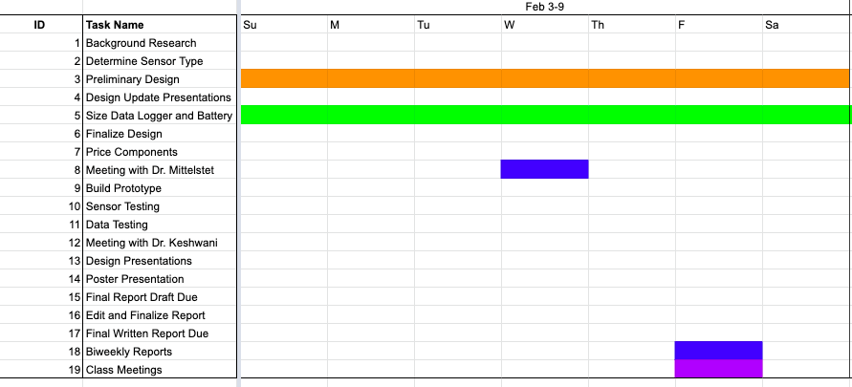

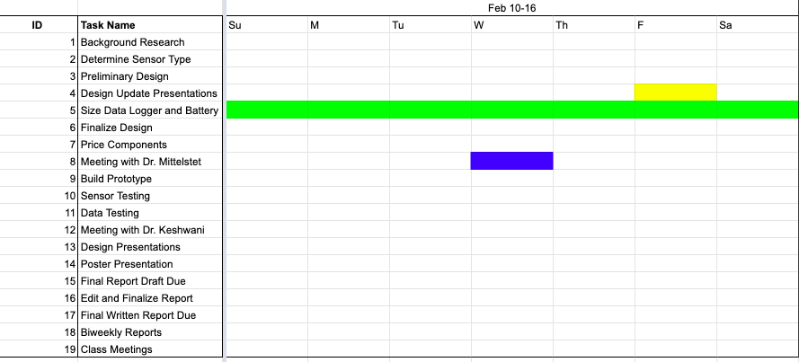

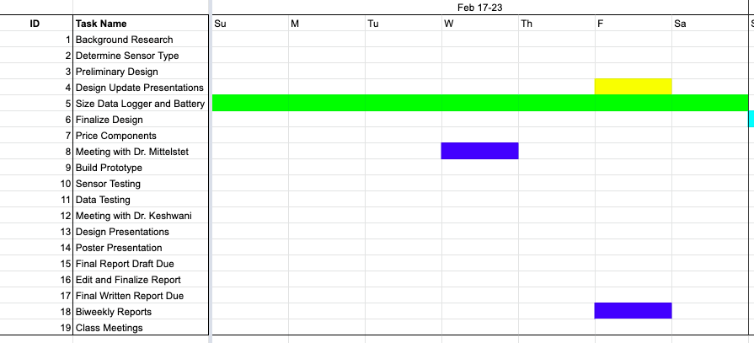

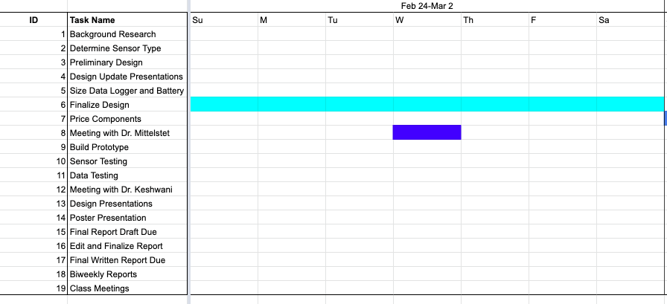

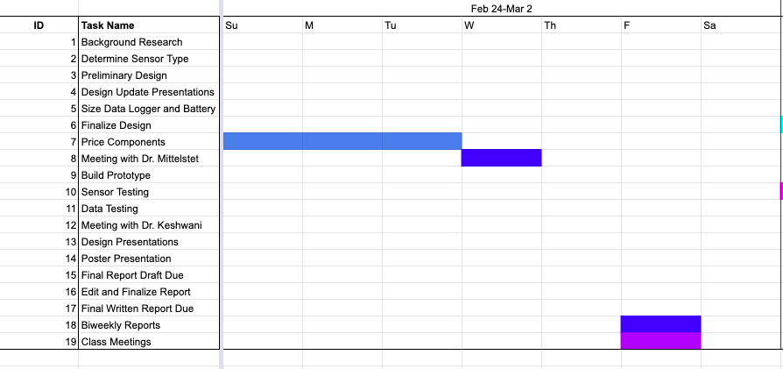

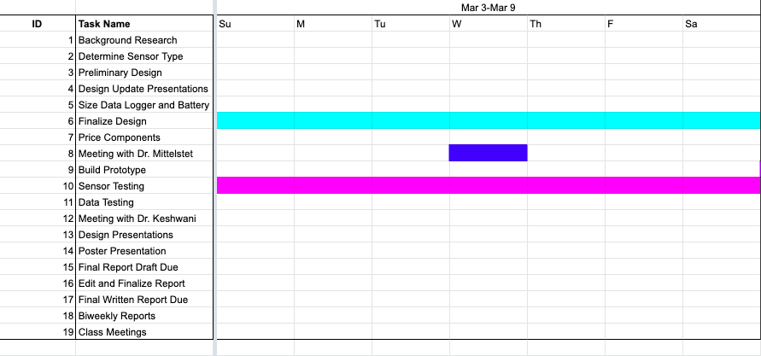

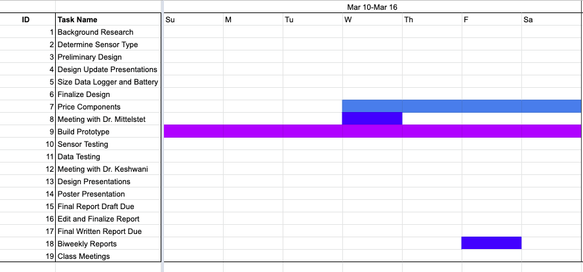

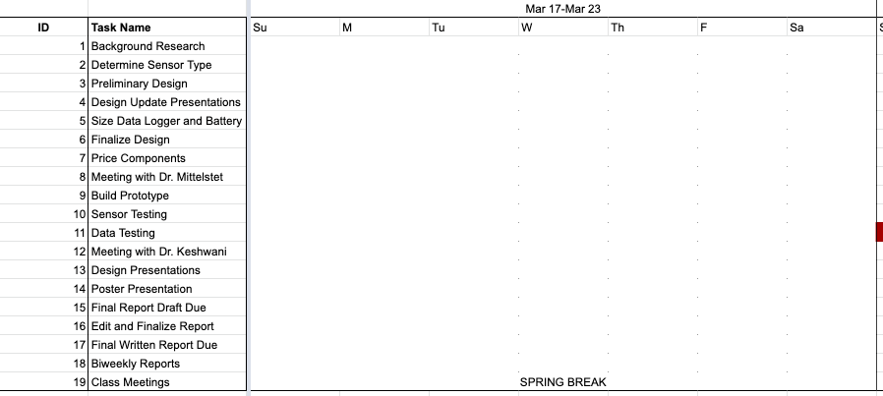

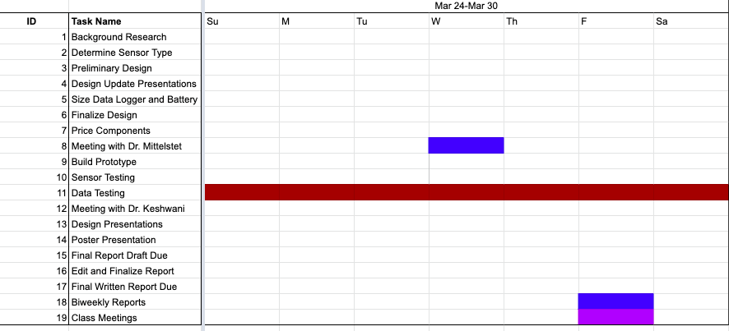

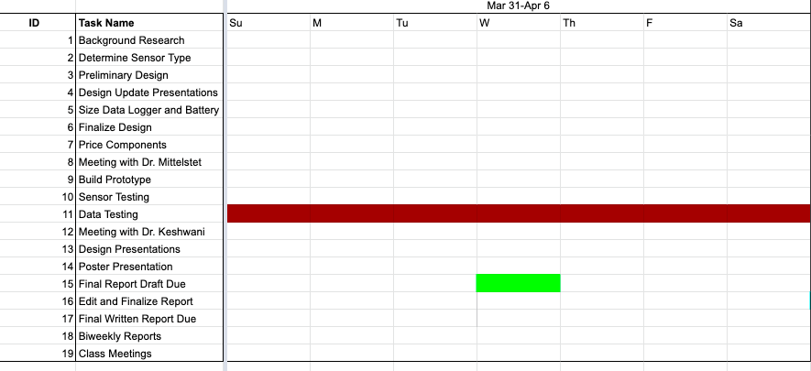

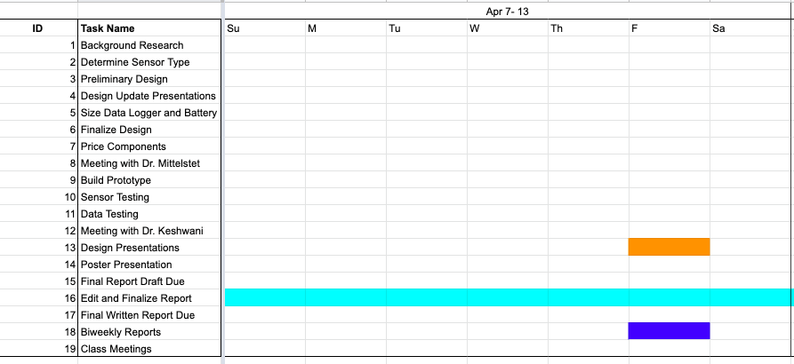

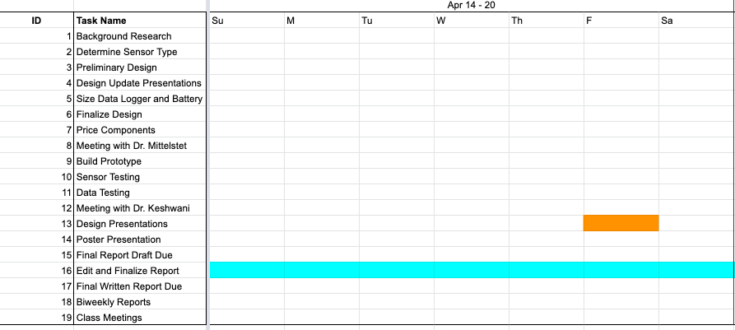

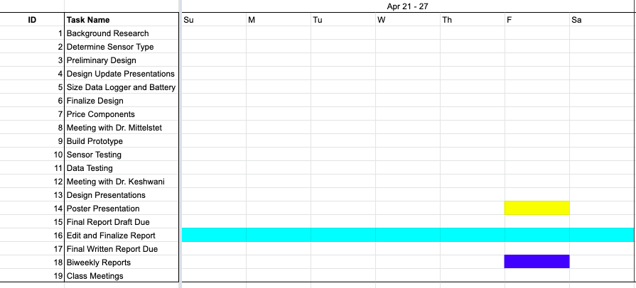

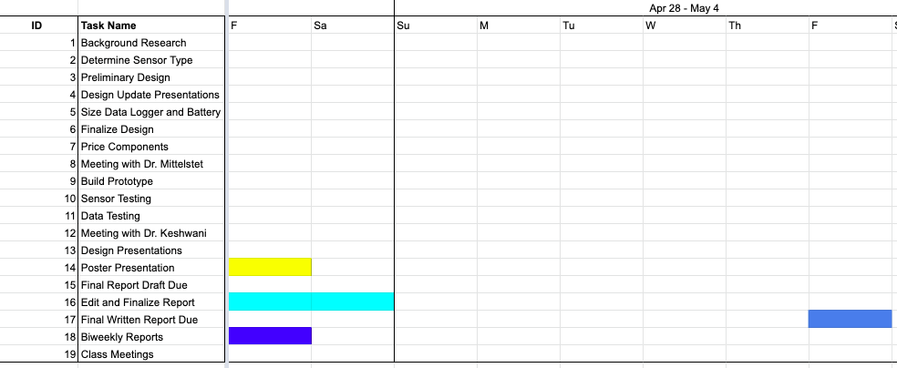

## Supporting Data/Drawings

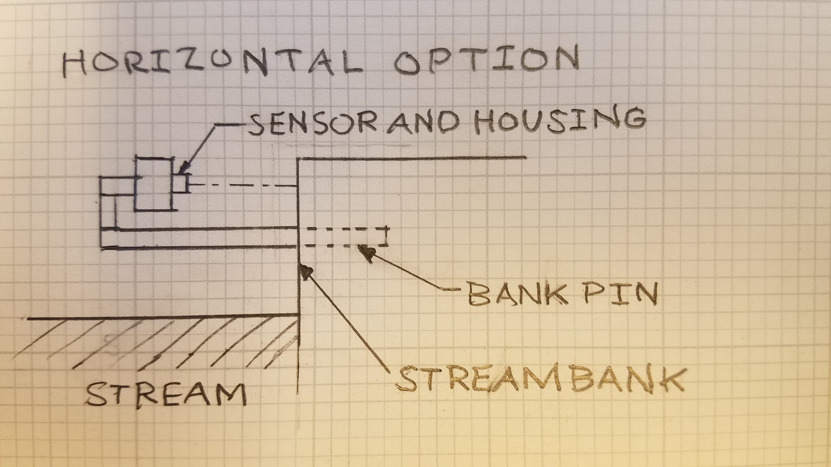

Figure 1. Design option with horizontal bank pin. Sensor measures distance to the nearside streambank.

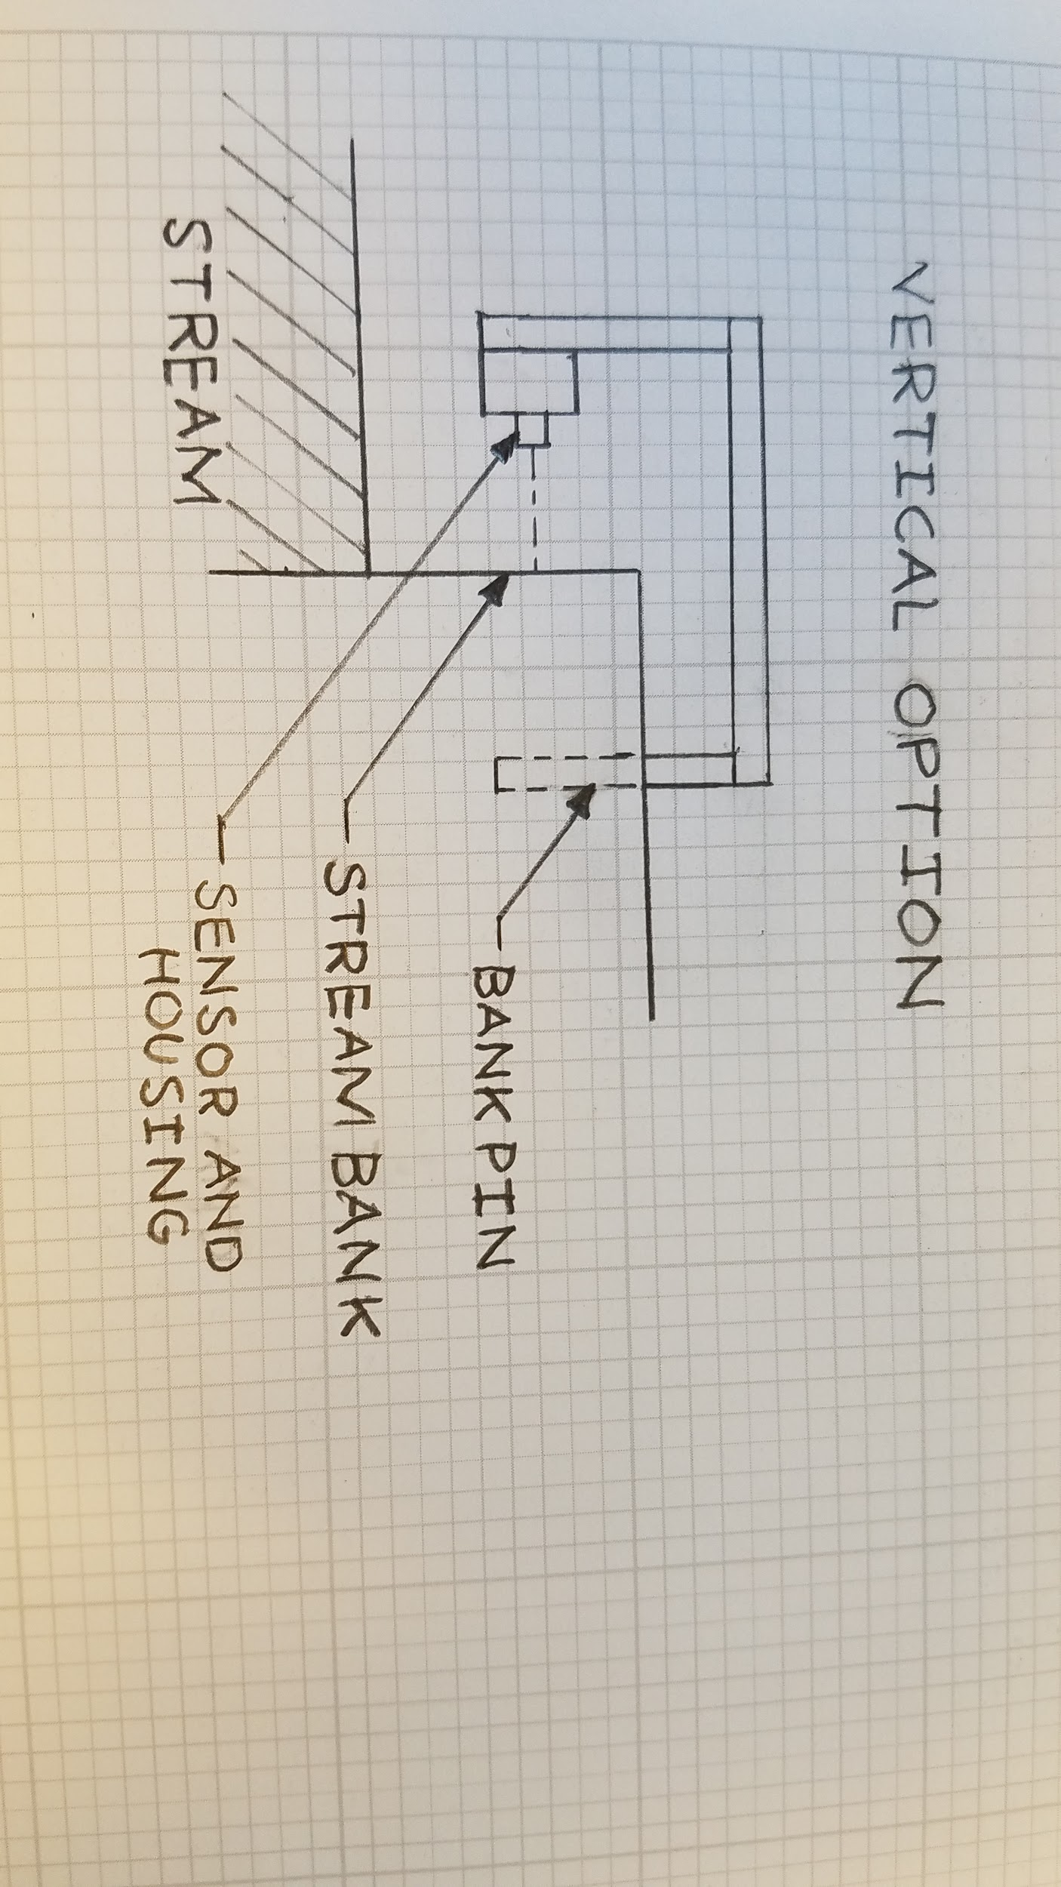

Figure 2. Design option with vertical bank pin and stream overhang. Sensor measures distance to nearside streambank.

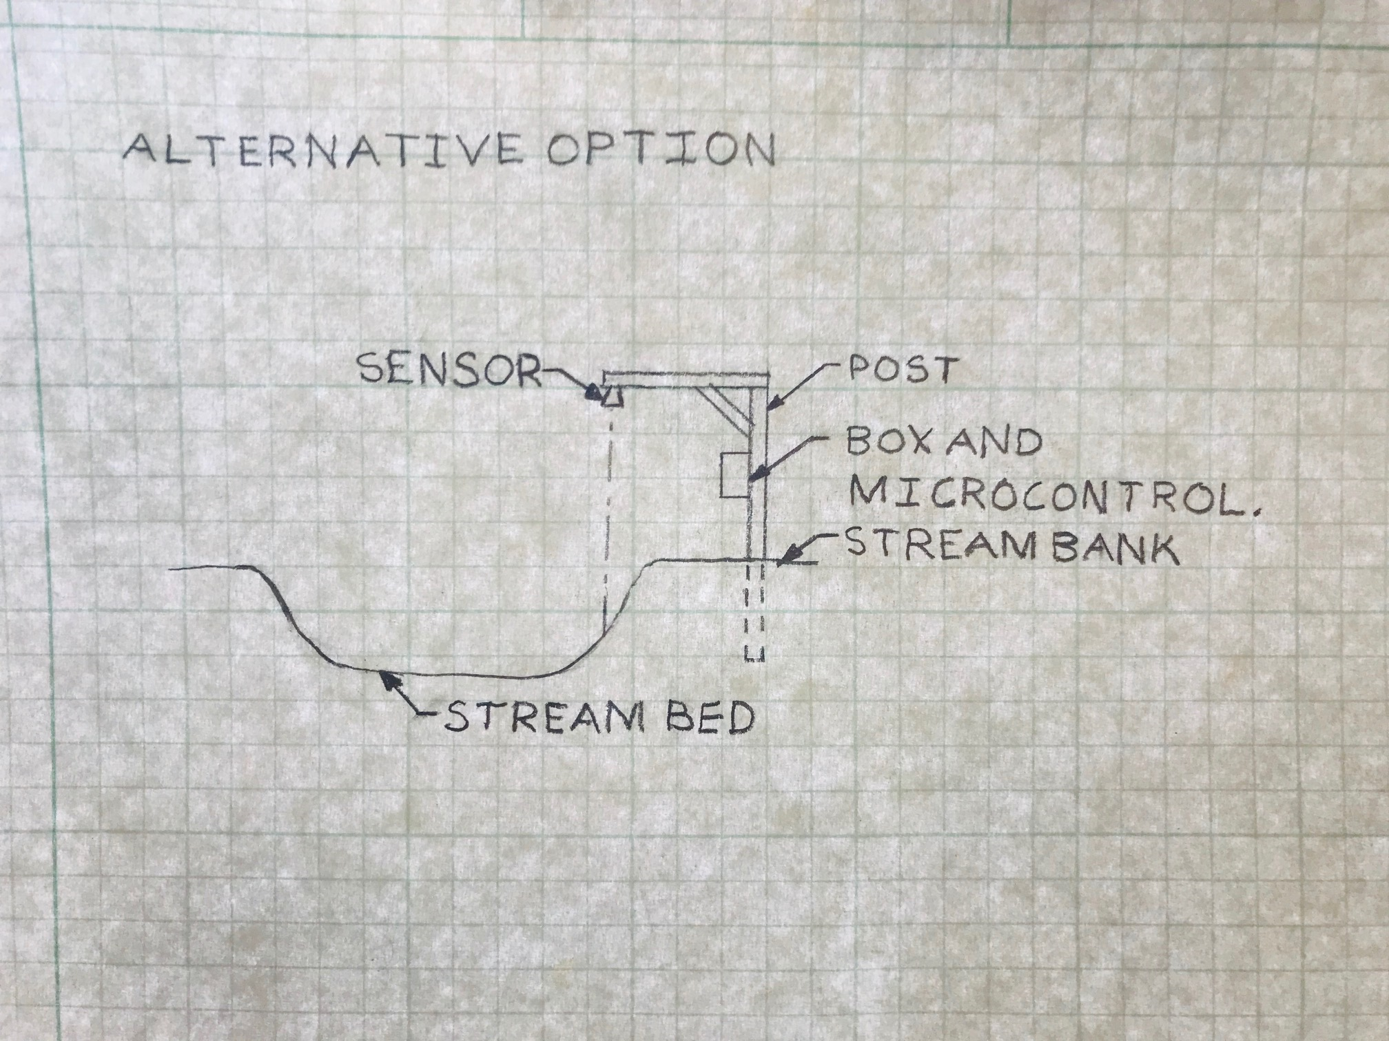

Figure 3. Design option with vertical bank pin and vertical reading. The sensor measures the vertical distance to nearside streambank.

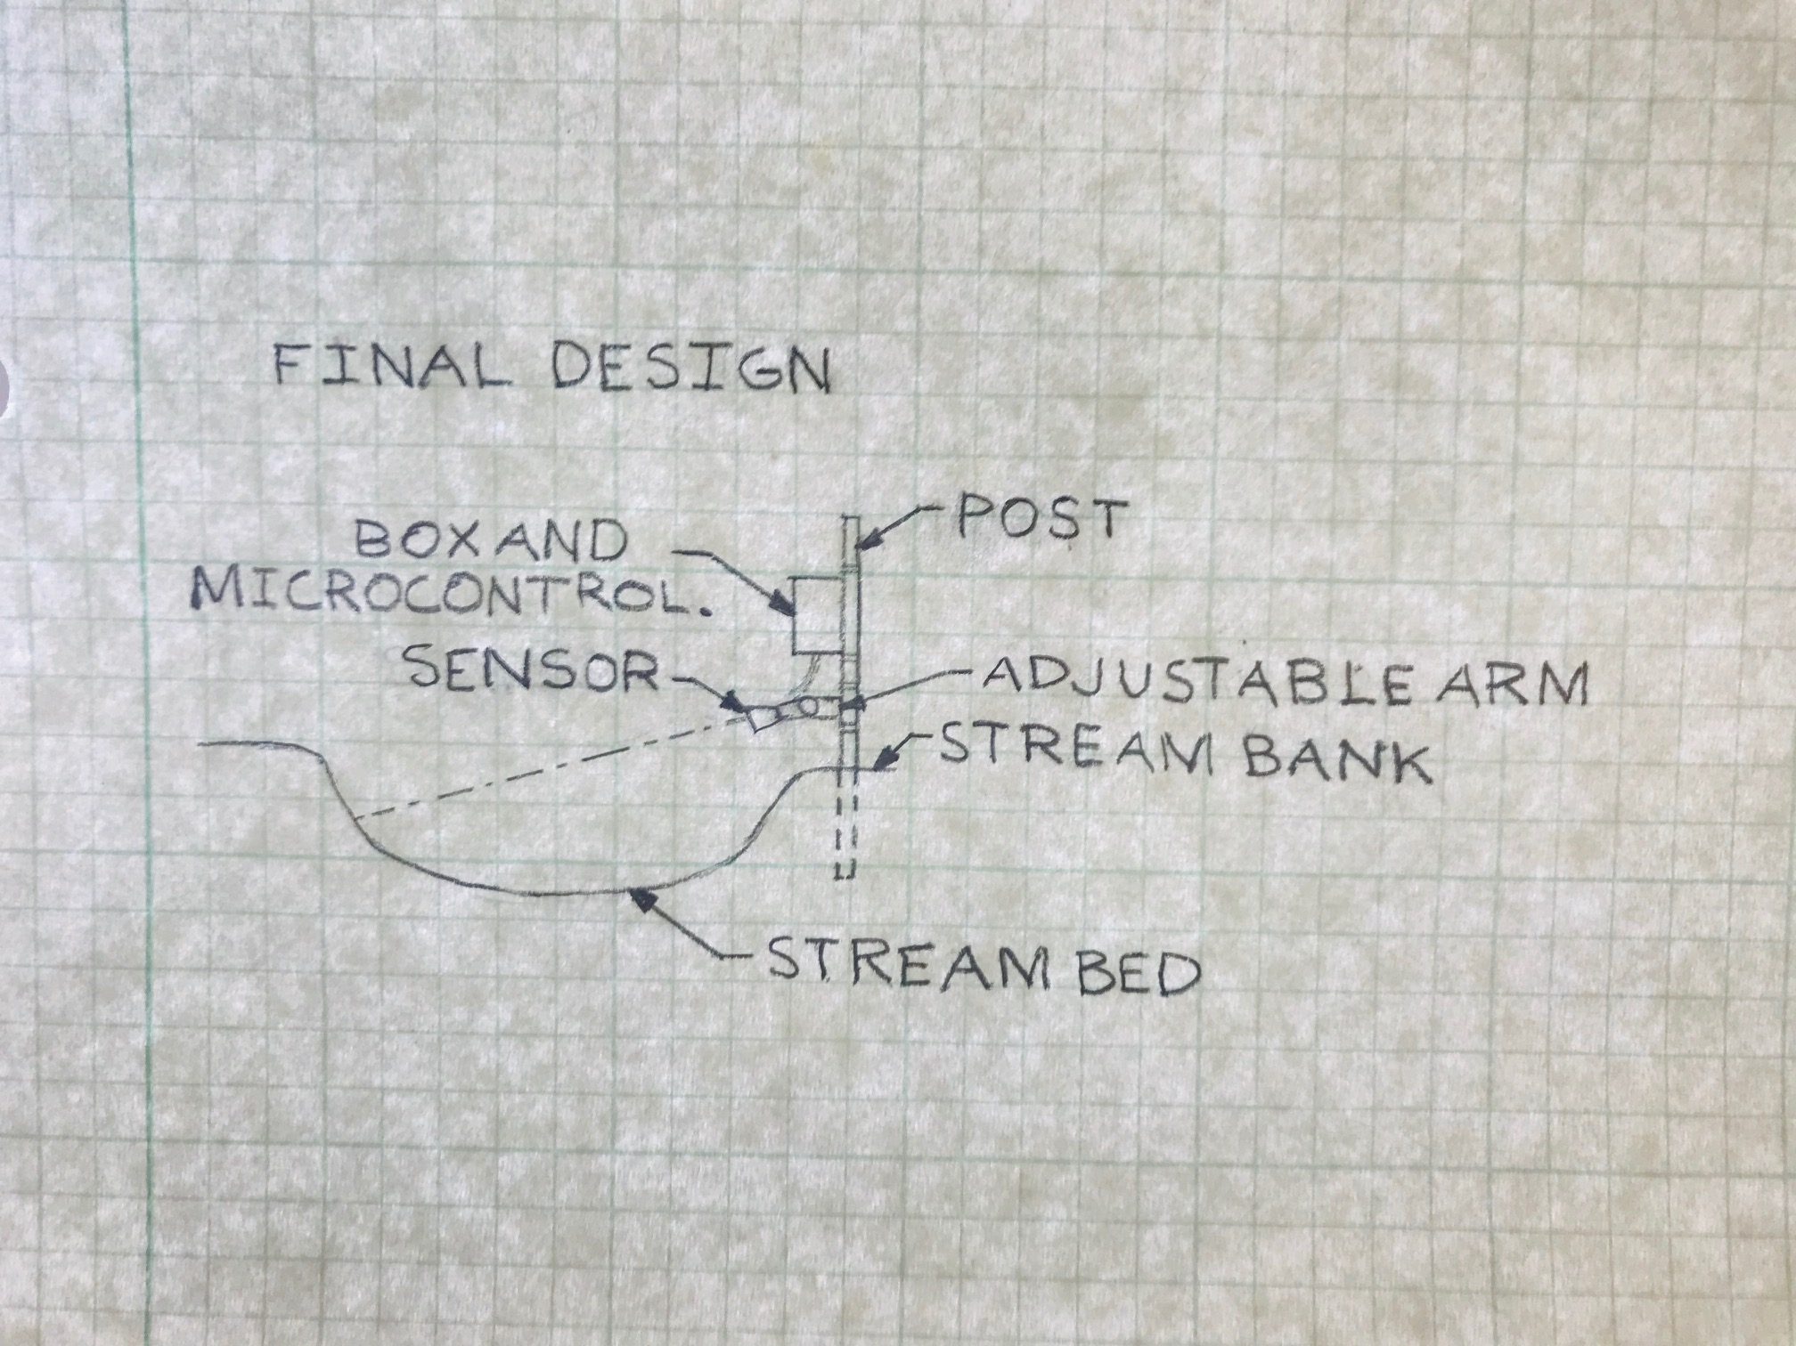

Figure 4. Design option with vertical bank pin and an adjustable sensor arm. Sensor measures distance to opposite side streambank.

## Bill of Materials

Table 1. List of items in final design and their cost

|  |  |  |  |  |
| --- | --- | --- | --- | --- |
| Item Description | Model Type/Part Number | Unit Cost | Quantity | Cost |
| Arduino Nano | V3.0 | $22.00 | 1 | $22.00 |
| Gikfun SD Storage Board TF Card Memory Shield Module for Arduino | EK1442 | $7.58 | 1 | $7.58 |
| SanDisk microSD Card and Memory Card Adapter | 32 GB | $15.00 | 1 | $15.00 |
| Adafruit DS3231 Precision RTC Breakout Board | DS3231, Part ID is 3013 | $13.95 | 1 | $13.95 |
| Aluminum Plate | 5 in x 2 in x 3/16 in | $0.89 | 1 | $0.89 |
| Aluminum Plate | 9 in x 2 in x 3/16 in | $1.55 | 1 | $1.55 |
| Aluminum Plate | 5 in x 1.5 in x 1/8 in | $0.50 | 1 | $0.50 |
| Aluminum Rod | 6 ft long | $20.00 | 1 | $20.00 |
| U-Bolts with Nuts and Washers |  | $2.30 | 4 | $9.20 |
| Hex Bolts |  | $0.50 | 6 | $3.00 |
| Nuts and Washers for Hex Bolts |  | $0.50 | 6 | $3.00 |
| Sensor | MB7389 HRXL-MaxSonar-WRMT | $109.95 | 1 | $109.95 |
| Electric Cable | Shielded Cable | $62.92 | 1 | $62.92 |
| Large Watertight Case | Outdoor Products Large Watertight Box | $7.00 | 1 | $7.00 |
| Speaker Wall Mount | Rocketfish 2pk SpeakerMount | $24.99 | 1 | $24.99 |
| Battery Pack | Griffin Reserve Power Bank 18,200mAh 2-Port USB Battery | $50.00 | 1 | $50.00 |
|  |  |  | **Total Cost** | $351.53 |

## 

## Arduino Code

#include <SPI.h> //for the SD card module

#include <SD.h> //for the SD card module

#include <Wire.h> //for the RTC

#include <DS3231.h>

RTClib RTC;

const byte rxPIN = 0; //indicate rx pin on arduino board

const byte txPIN = 1; //indicate tx pine on arduino board

String distance = String("");

long distanceSum = 0L; //

long distanceAverage;

char inChar = '0';

int i = 0;

int chipSelect = 4; //indicate pin where CS port for SD Card Module is connected

// Create a file to store the data

File myFile;

void setup() {

pinMode(rxPIN, INPUT);

pinMode(txPIN, OUTPUT);

Serial.begin(9600);

Wire.begin();

Serial.print("Initializing SD card...");

if(!SD.begin(chipSelect)) {

Serial.println("initialization failed!");

return;

}

Serial.println("initialization done.");

//open file

myFile=SD.open("DATA.txt", FILE_WRITE);

// if the file opened ok, write to it:

if (myFile) {

Serial.println("File opened ok");

// print the headings for our data

myFile.println("Date,Time,Distance mm");

}

myFile.close();

}

void loggingDateTime(){

DateTime now = RTC.now();

myFile = SD.open("DATA.txt", FILE_WRITE);

if (myFile) {

myFile.print(now.year(), DEC);

myFile.print('/');

myFile.print(now.month(), DEC);

myFile.print('/');

myFile.print(now.day(), DEC);

myFile.print(',');

myFile.print(now.hour(), DEC);

myFile.print(':');

myFile.print(now.minute(), DEC);

myFile.print(':');

myFile.print(now.second(), DEC);

myFile.print(",");

}

myFile.close();

Serial.print(now.year(), DEC);

Serial.print('/');

Serial.print(now.month(), DEC);

Serial.print('/');

Serial.print(now.day(), DEC);

Serial.print(' ');

Serial.print(now.hour(), DEC);

Serial.print(':');

Serial.print(now.minute(), DEC);

Serial.print(':');

Serial.print(now.second(), DEC);

Serial.println();

}

void loggingDistance(){

myFile = SD.open("DATA.txt", FILE_WRITE);

if (myFile) {

Serial.println("open with success");

myFile.println(distanceAverage);

}

myFile.close();

}

void loop() {

while(i < 40) {

digitalWrite(txPIN, HIGH);

if(Serial.available()){

inChar = Serial.read();

if(isDigit(inChar)){

distance += inChar;

}

if (inChar == '\r'){

distanceSum = distanceSum + distance.toInt();

distance = String("");

i++;

}

}

}

distanceAverage = distanceSum/40;

loggingDateTime();

loggingDistance();

Serial.println(distanceAverage);

Serial.print('\n');

i = 0;

distanceSum = 0;

distanceAverage = 0;

delay(300000);

}

## Part Documentation

Sensor data sheet

Arduino Nano data sheet